Max Martenot, A digital re-imagination of Ondes Martenot

Avrosh Kumar
MSMT, Georgia Institute of Tech Atlanta
+1 (470) 263 2153
avroshk@gatech.edu

ABSTRACT
This paper discusses Max Martenot, a Max/MSP patch inspired by Ondes Martenot, an early electronic musical instrument invented in 1928. The patch uses two forms of input, a continuous slide controller and a wireless gyrometer-cum-accelerometer chip worn on a hand glove. The main component of the patch is a combination of oscillators and filters that emulate a wide range of timbres from vocal-sounding tones to feedback delays. The paper elaborates on the building process of the patch, the major challenges, the mappings and the expansion planned.
Keywords
Ondes Martenot, Max MSP, arduino, ribbon controller, glissando, oscillator

INTRODUCTION & MOTIVATION
Ondes Martenot and Theremin were one of the first electronic intruments and yet they hold their own place in the era of digital synthesizers due to their unique sounds. Maurice Martenot [1], the creator of Ondes Martenot, was a radio telegrapher during the World War I. He was intrigued by the sweeping sounds of the radio waves and used that as the basis of sound generation in his instrument. He used a Beat Frequency Oscillator to create sounds by the “heterodyning” two high frequency oscillators. The dial of one of the the oscillators i.e. the variable capacitor is operated using a sliding ring controller [2]. Being a cellist himself, he wanted to introduce an instrument that could fit in with the orchestral setup of the 20th century. He added an expression key to be operated by the left hand, a button that controlled the note on, note off, attack and sustain of the note. The expression key was supposed to emulate the “bowing” of a stringed instrument. The keyboard was initially added for reference of the pitch and later as a playable keyboard.
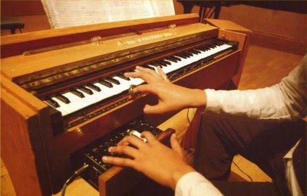
Figure 1. Expression key & Sliding ring controller [2]
Ondes Martenots have been adopted by many early composers like Olivier Messiaen and a few modern composers like Jonny Greenwood. Despite the popularity of this instrument, the ribbon controller has not been replicated enough to be easily re-creatable and used in different setups. One of the reasons I’d assume is that the patents have not been released into the public domain yet but also original Ondes Martenots are very costly to obtain. I took this opportunity to recreate the instrument digitally where it’s sound engines can be manipulated without undertaking the task of recreating the circuitry. Besides, it is an opportunity to create the sliding ring controller which interests me due to it’s continuous input capability.

Parts
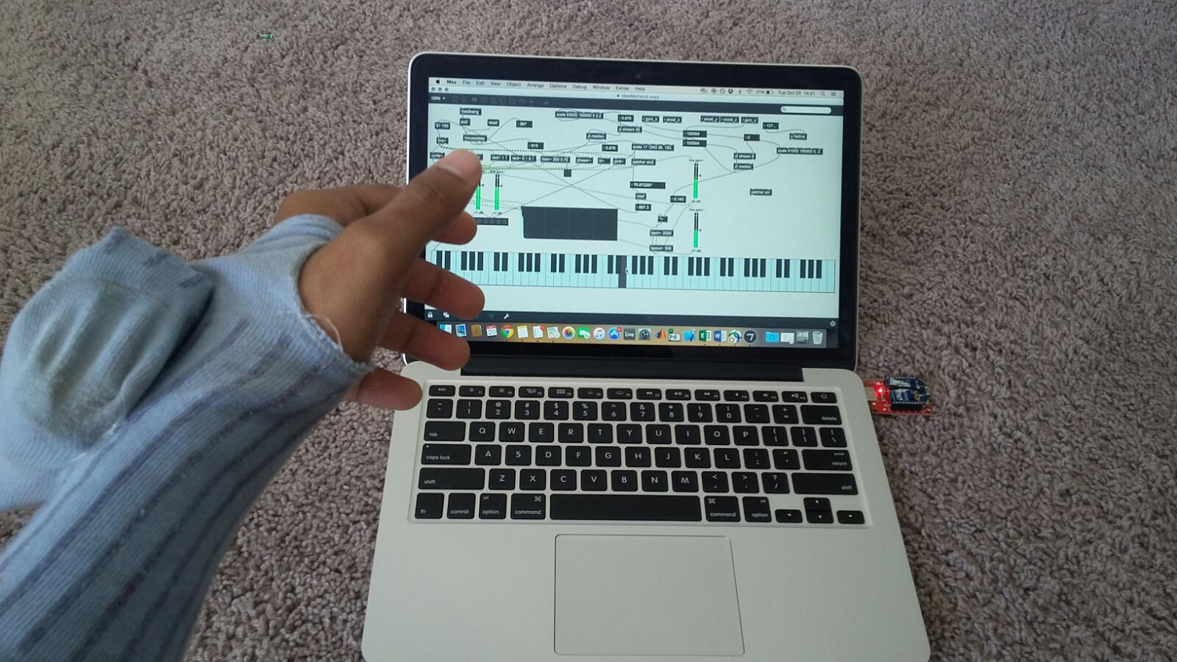
Figure 2. Max Martenot – work in progress

The project consists of three parts,
- A Max/MSP patch acting as the sound engine and a user interface to select or switch between sound engines.
- A glove mounted with gyrometer/accelerometer chip on an Arduino Pro Mini. It communicates with the Max patch using XBee bluetooth transmitter and receiver. It acts as the expression key to control the note on, off, attack and various dynamics of the note being played.
- A ring slider control that reads data of the position of the slider using a potentiometer and sends the data to the max patch through Arduino Uno connected to a serial port. The work in the slider is still in progress and hasn’t been completed yet. I referred to Dana Countryman’s website [3] to get some ideas for the controller.

Sound Synthesis

The Ondes Martenot uses simple waveforms and their combinations to create different timbres.

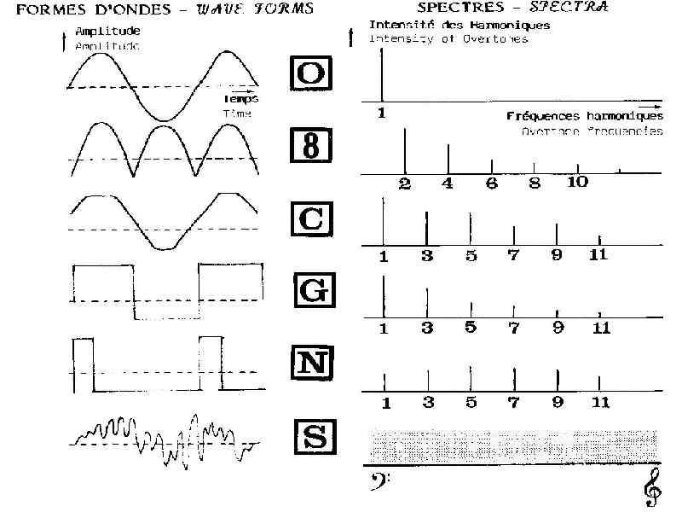

Figure 3. Waveforms of sound synthesis engines [4]

I have emulated these waveforms in Max and added a few more synthesis engines to this list to create an interesting range of timbres. Some of my engines include sine, triangle, saw, phasor, odd harmonic sin, etc. The biggest advantage of using max is that we can add control knobs to these parameters of these engines and add or remove new engines very easily. The matrix control object allows us to chose more than one engines at the same time thus allowing us to create numerous possible combinations of timbres.

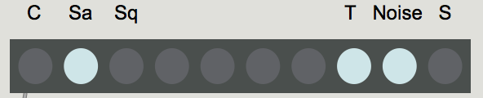
Figure 4. Matrix Control for sound engines in Max MSP
Another addition to my patch included use of delay which added the eerie quality to the sound reminiscent of the sound of the actual instrument.

MAPPING

There are two main mappings in this project.
- The slider control mapped to control the pitch. This input is read as linear potentiometer readings as the pot turns when we move the ring. I used “mtof” conversion to map the linear readings to the non-linear frequency scale. I also maintained the continuous input and its conversion to frequency without any quantization. It may seem difficult to imagine playing the instrument without any quantization of notes but a drawing of a keyboard over the slider board helps the player know which note is being played. The continuous input allows two main features to the playability of the instrument – the glissando and vibrato. I will go into more details about this when my work on the slider in complete. For now, I have mapped the pitches to the x-axis readings of my mouse pointer on screen over a “kslider” object keyboard as a visual aid.
- The gyrometer/accelerometer chip sends data to Max over a serial port as bytes. The following patch shows the parsing of the stream of data into 6 numbers – gyro_x, gyro_y, gyro_z, accel_x, accel_y & accel_z. The current mapping only uses gyro_z and accel_z as inputs to shape the envelope of the sound, i.e. emulating the action of turning a knob counter-clockwise increases the gain of the signal. Doing the action slower or faster one can control the attack and decay analogous to the action of bowing.
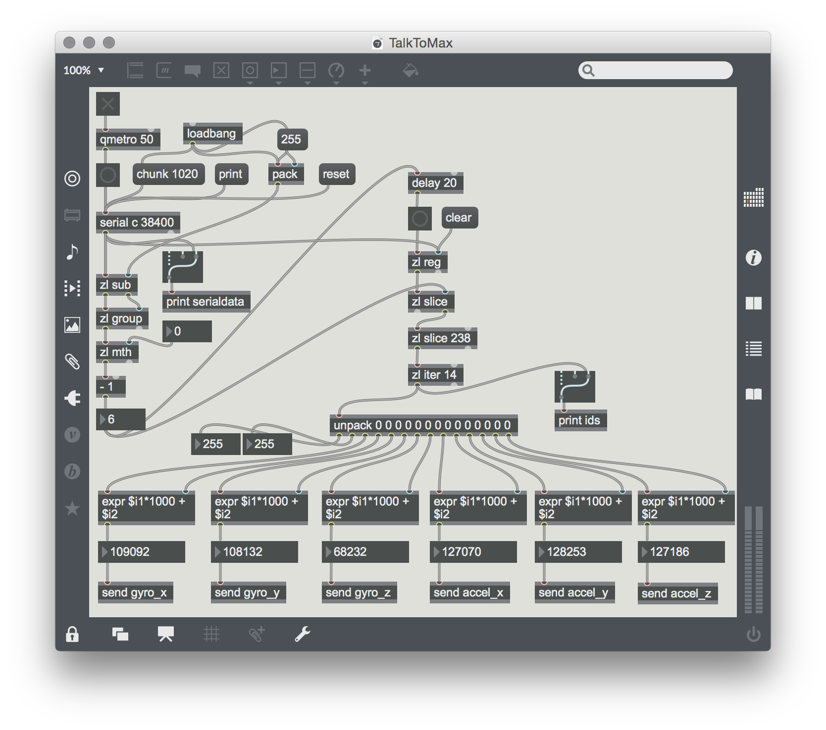
Figure 5. Parsing of gyro-meter/accelerometer readings

I have also performed smoothing of the incoming values using median filter to get past jitters in the movements of the left hand. The use of ramp generator (line~) also helped in creating a smooth rise and fall of the envelope without which you would hear clicks of sounds whenever the envelope changed.

STRENGTHS, WEAKNESSES AND FUTURE DEVELOPMENT

The continuous input worked very well in emulating the sound of the Ondes Martenot. However, the expression glove mappings are underutilized and there is a lot of room to create more mappings with it. I plan to control the number of partials of the timbres with the glove as well as some delay characteristics. I also plan to use convolution reverb to recreate some atmospheric effects that the actual Ondes Martenot employs. I also plan to finish the work on the slider control within coming two weeks. The physical aspect of the slider is important for the playability of the instrument.

CONCLUSION

Ondes Martenot is an early electronic instrument which hasn’t been revived too often. This project is an attempt to create a digital model of this instrument with controllers similar to the original instrument. With the digital patch it’s easier to add, remove or edit the sound synthesis engines and the gyrometer/accelerometer readings allows us to create more mappings to shape the sound.

REFERENCES
- Maurice Martenot. (2015). In Encyclopædia Britannica. Retrieved from http://www.britannica.com/biography/Maurice-Martenot Date accessed: 20th Oct, 2015
- Vintage Keyboard, The Ondes Martenot. (2010). http://tecladosyteclistas.blogspot.com/2010/09/teclado-vintage-el-ondas-martenot.html. Date accessed: 20th Oct, 2015
- Dana Countryman. (2008). Ondes Martenot Controller Project, http://www.danacountryman.com/martenot_project/martenot.html. Date accessed: 20th Oct, 2015
- Waveforms & Spectra of Martenot (2010), http://electro-music.com/forum/phpbb-files/8126_295.jpg Date accessed: 20th Oct, 2015

